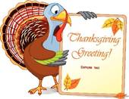
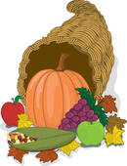
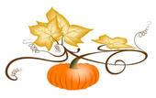
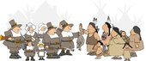
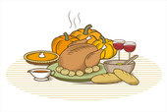
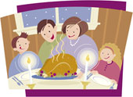
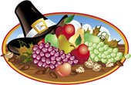
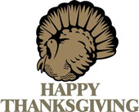
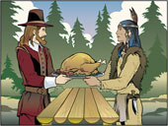

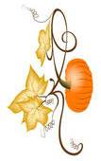
Across

7. Soon the Pilgrims and the ___________ became good friends.
8. The Indians showed the Pilgrims how to ____________ crops.
9. The traditional Thanksgiving meal consists of roast _________.
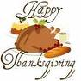
12. The Pilgrims left Great Britain in 1620 because of _______ persecution.
14. Thanksgiving is celebrated on the last ___________ of November.
15. The Pilgrims left Britain on a small ship called the ___________.
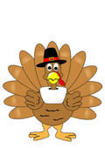
Down
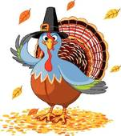
1. Thanksgiving is an _____________ festivity.
2. The tradition started with the ___________.
3. The Pilgrims arrived in December 1620 and founded ___________.
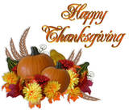
4. Governor William Bradford, the Pilgrim leader, decided to celebrate with a _________ for the Pilgrims and the Indians.
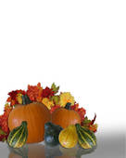
5. The traditional Thanksgiving meal consists of __________ sauce.
6. Thanksgiving is a special day for ___________.
10. In 1621 the ___________ was good.
11. The traditional Thanksgiving meal consists of sweet _________.
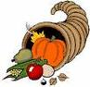
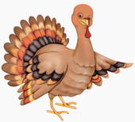
13. Governor William Bradford wanted to give thanks to _______.

